



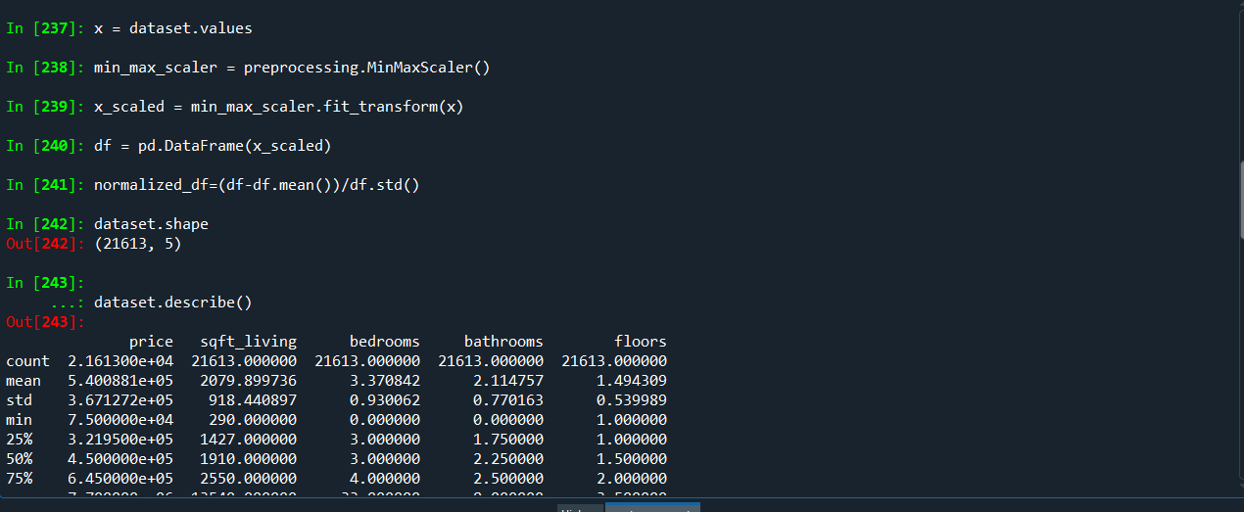

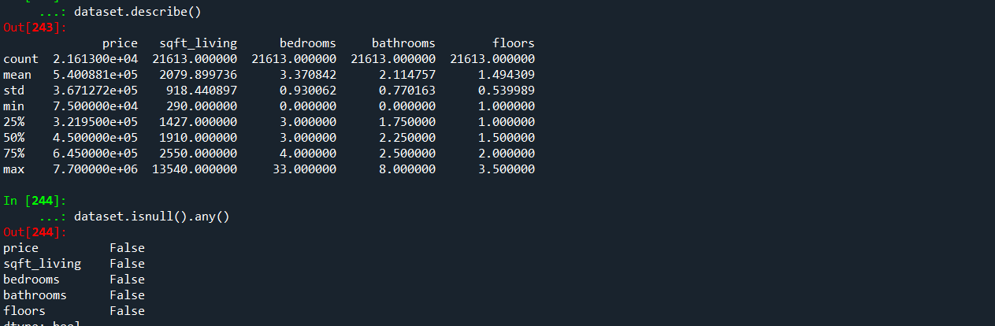

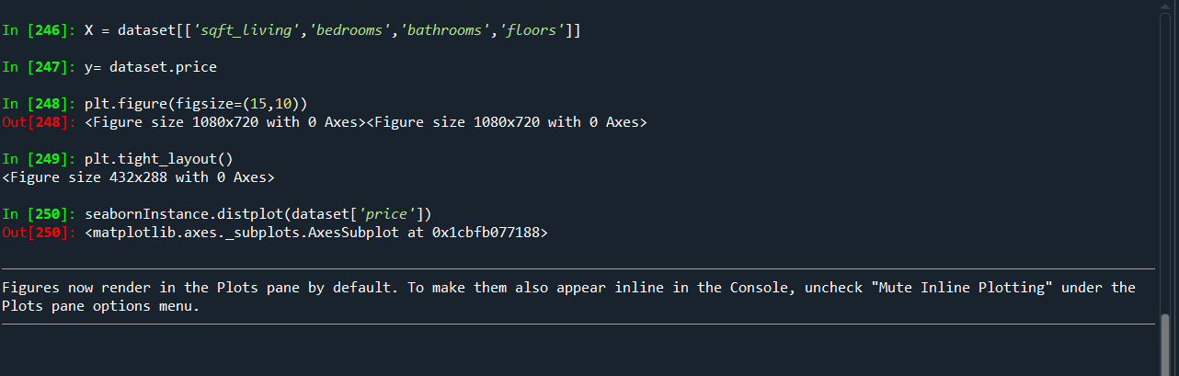

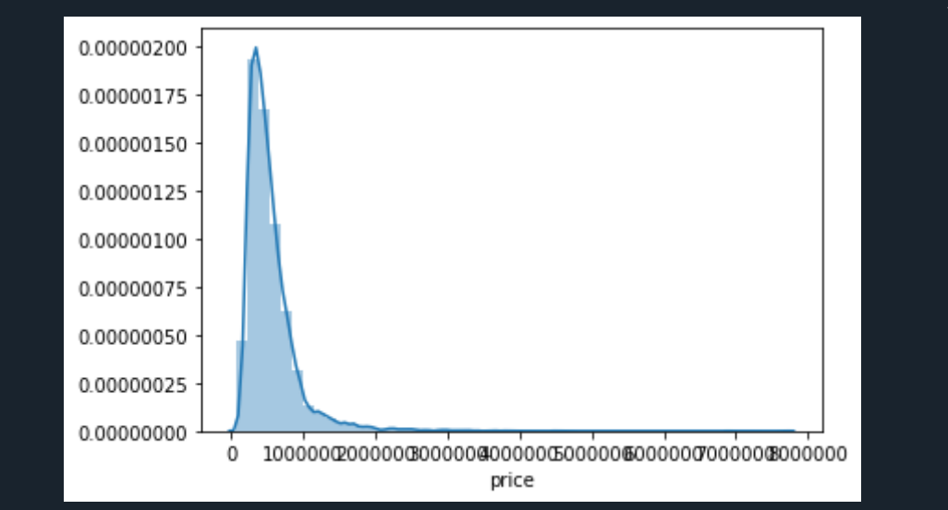

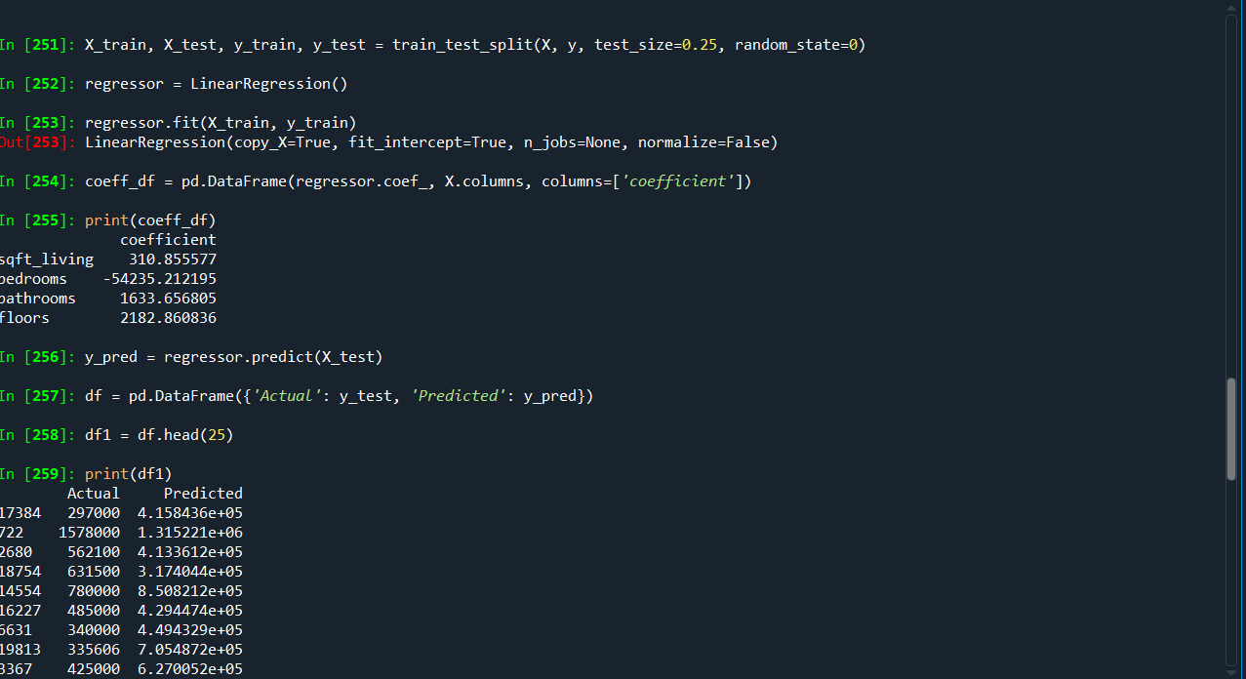

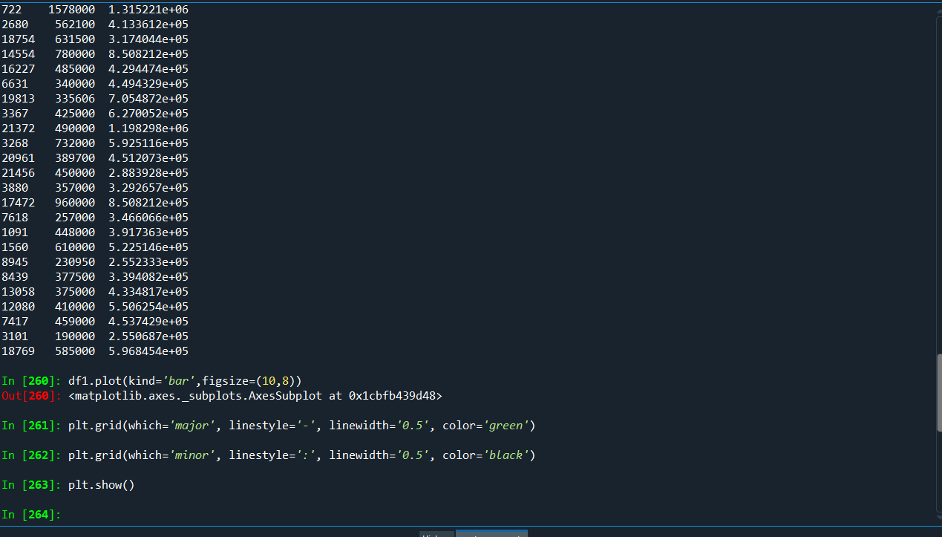

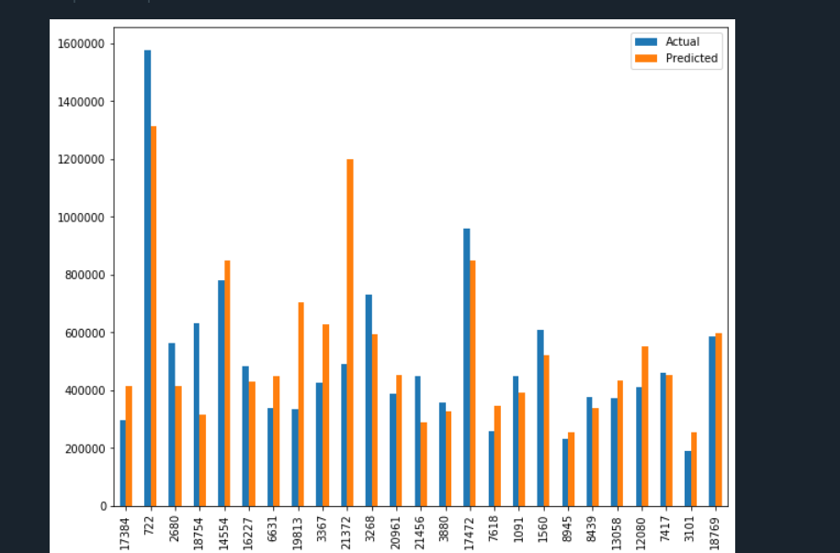

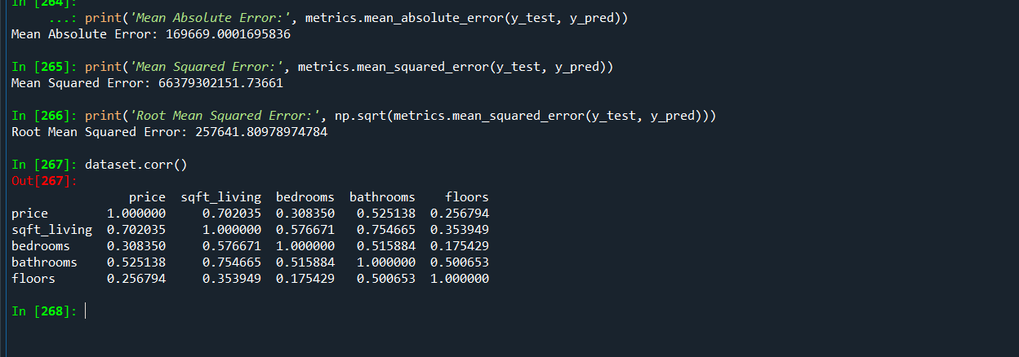

**Inference:**

**1.All the independent variables like sqft_living , bedrooms , bathrooms , floors are positively correlated .**

**2. price and bedrooms are weakly correlated as the value is .308 because it is lesser than .5**

**3. price and sqft_living is strongly correlated as the value is .702 and it is above .5**

**4.price and bathrooms are moderately correlated as the value is .525 which is almost near to .5**

**5. price and floor are weakly correlated a sthe value is .256 which is lesser than .5**



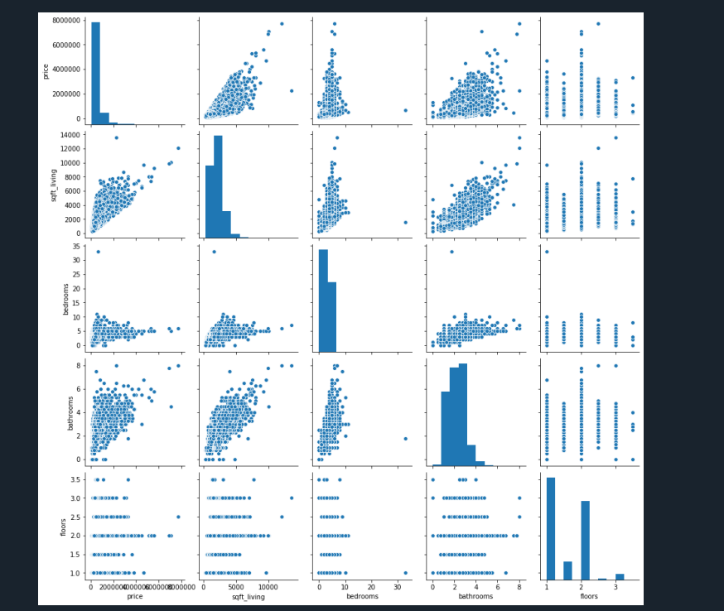



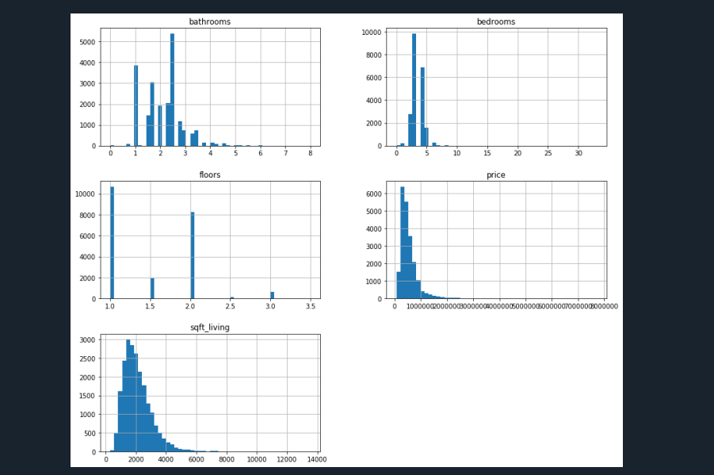

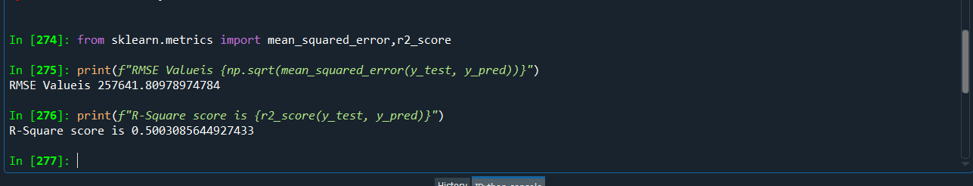

**Here the R Square vale 0.5003085644927433 its a 50%**